/*Program for an applet which displays a moving banner “**Computer Science”**

Name:Anand Joshy K

Class :S7 CS

Roll No:7

Date:31/07/17

*/

Program

import java.awt.*;

import java.applet.*;

/*

<applet code="applet_3" width=300 height=150>

</applet>

*/

public class applet_3 extends Applet implements Runnable {

String str=" Computer Science";

Thread t=null;

public void init()

{

t=new Thread(this);

t.start();

}

public void run()

{

char ch;

while(true)

{

try

{

repaint();

Thread.sleep(1000);

ch=str.charAt(0);

str=str.substring(1,str.length());

str+=ch;

}

catch(InterruptedException e){}

}

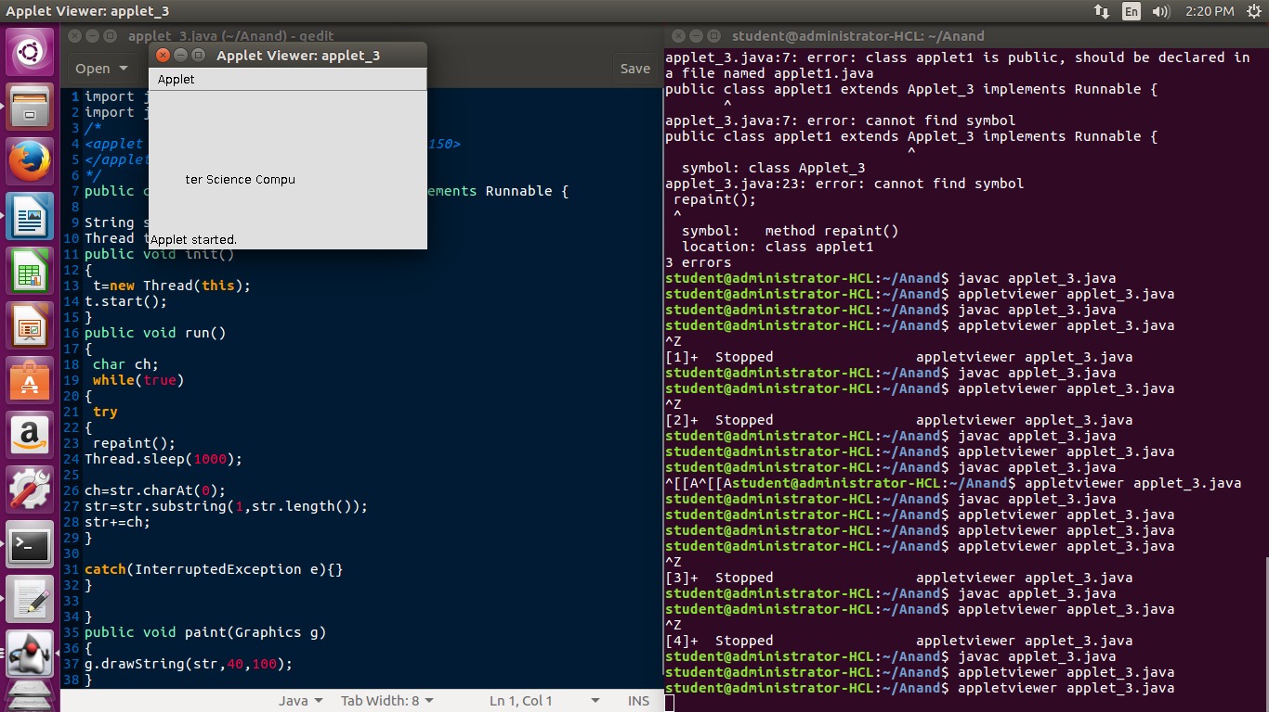}

public void paint(Graphics g)

{

g.drawString(str,40,100);

}

}

OUTPUT